Java Game Suite User Guide

August 2021

# 

**REVISION HISTORY**

|  |  |  |  |
| --- | --- | --- | --- |
| **Version** | **Date** | **Comments** | **Author** |
| **0.1** | **31 August 2021** | **First version of user guide created** | **Oyewole** |
|  |  |  |  |

**TABLE OF CONTENTS**

1. Introduction…………………………………………………………………...3
2. System Requirements………………………………………………………….3
3. Installation……………………………………………………………………..4
4. Operation……………………………………………………………………….4

# 

# 

# Introduction

1. The Java Game Suite program is a simple GUI-based application that provides entertainment to users by allowing them to play several simple single player computer games. The user will be presented with an interface that indicates the available games: a maze, snakes, Sudoku, wordsearch, and a slider puzzle. The user will be able to select a game from the suite and launch it from that interface.

# System Requirements

Java Game Suite Minimum System Requirements:

1. **Operating System:** Mac, PC, or Linux
2. **Memory:** Minimum of 128 MB RAM
3. **Processor:** Pentium 266 Mhz processor or faster
4. Latest version of Java compatible with your OS. ([Link](https://www.java.com/en/download/manual.jsp))

# Installation

1. Source code can be downloaded from the following link: [Java Game Suite](https://github.com/tsanusi/CMSC495-Group-Charlie-Java-Game-Suite.git)

2. Navigate to the saved destination of the code and extract the zip file contents.

3. Navigate into the /disk directory and double click on the Main executable

File to run the program.

# Operation

1. Select “Maze” from the menu to lunch the game.

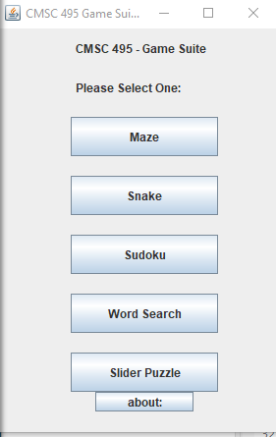

1. Select “Snake” from the menu to lunch the game.



1. Select “Sudoku” from the menu to lunch the game.



4. Select “Word Search” from the menu to lunch the game.



5. Select “Slider Puzzle” from the menu to lunch the game.



6. Select “about” from the menu to learn more about each game.

